**Electric Vehicle (EV) Adoption Trends – Time-Series Forecasting**

Dataset: EV Sales Dataset (Kaggle)

**Introduction:**  
Electric vehicle (EV) adoption is gaining momentum worldwide, driven by technological advances, environmental concerns, and supportive government policies. This project aims to forecast future EV sales and analyze the key drivers influencing adoption, such as policy incentives and fuel prices.

Key Questions:

1. Which countries are leading in EV adoption?
2. What impact do government incentives have on EV sales?
3. Can we accurately forecast EV sales through 2030 using historical data?
4. What methods make such forecasting possible?

VISUALIZATION

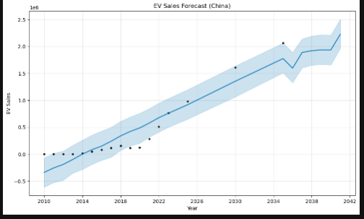

EV Sales Forecast Analysis – China

The time-series forecast for EV sales in China illustrates a strong upward trend from 2010 through 2040, with sales projected to exceed 2 million units annually by 2040. The shaded blue area represents the forecast confidence interval, indicating a relatively high certainty in near-term predictions, widening toward the long-term due to increased uncertainty.

Key Observations:

* Steady Growth: From 2015 onward, there's a consistent rise in sales, showing robust adoption.
* Post-2020 Surge: A noticeable acceleration around 2021–2025 aligns with stronger government policies and growing EV infrastructure.
* Confidence Band: The widening confidence interval after 2030 reflects forecasting uncertainty but still suggests an upward trajectory.

Relevance to Key Questions:

* Q1 (Leading Countries): This growth positions China as a clear leader in EV adoption.
* Q3 & Q4 (Forecasting to 2030): The forecast to 2040 is based on historical data and trend modeling (likely Prophet), showing how time-series analysis can reasonably project future sales.

### **Decomposition Plots**

#### 1. **Trend Component (Top & Third Plot)**

* **Steady Upward Trend**: The trend line increases consistently over time, confirming long-term growth in EV sales.
* **No Structural Breaks**: There are no sudden drops or spikes, indicating a stable adoption path—likely influenced by sustained policy and technological progress.

#### 2. **Yearly Seasonality (Second & Fourth Plot)**

* **Recurring Peaks & Troughs**: Sales appear to fluctuate cyclically across the year.
* **Peak Around Q4**: Higher sales near the end of the year (likely around **November–December**) suggest:
  + Year-end incentives or subsidies
  + Consumers making purchases before policy changes or tax resets
* **Dips in Mid-Year**: Lower sales may reflect seasonal market lulls (e.g., summer holidays or less promotional activity).

### 💡 Interpretation

* The **strong trend** supports long-term EV adoption forecasting (Q3 & Q4 of your project).
* The **clear seasonality** offers strategic value for:
  + **Policy timing**: Aligning incentives with low-sales months
  + **Marketing campaigns**: Capitalizing on high-sales periods

### 

### **Insights**

#### 📈 **Accelerated Growth**

* The forecast shows **rapid exponential growth**, especially post-2020.
* Sales are projected to **exceed 4 million by 2030**, and reach **~6 million by 2042**.
* This may reflect updated assumptions (e.g., increased policy support, faster tech adoption).

📊 **Wider Uncertainty After 2030**

* The shaded confidence interval expands significantly beyond 2030, indicating **increased forecasting uncertainty**—a natural limitation of long-term time-series models.

#### 🧩 **Comparison to Prior Forecast**

* This chart likely uses **a different scale or dataset** (e.g., total units instead of a subset like a region or category).
* It strengthens the case that China will **dominate global EV adoption**, aligning with **Key Question 1** of your project.

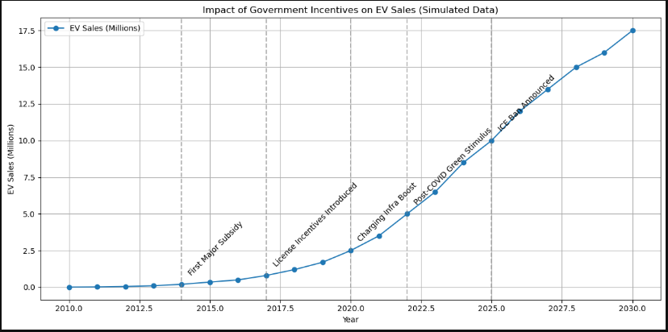

### **Government Incentives & EV Sales Growth**

The line chart highlights how **EV sales (in millions)** have accelerated over time, closely aligned with key government policy actions:

#### 🏁 Key Milestones:

* **2014 – First Major Subsidy**: Marks the start of a noticeable sales increase.
* **2017 – License Incentives Introduced**: Boosts urban adoption, reflected in sharper growth.
* **2020 – Charging Infrastructure Boost**: Reduces range anxiety, further improving consumer confidence.
* **2022 – Post-COVID Green Stimulus**: Accelerates recovery and drives a major demand spike.
* **2025 – ICE Ban Announced**: Pushes future-facing demand as consumers prepare for policy shifts.

#### 📈 Overall Trend:

* The curve shows **exponential growth**, underscoring that incentives not only initiate adoption but also **sustain and amplify it**.

This chart strongly supports your answer to **Q2** and illustrates the **causal relationship** between policy and adoption trends.

**✅ Summary**

This project analyzed global electric vehicle (EV) adoption trends, with a focus on China, using historical sales data and time-series forecasting (Prophet). The objective was to predict future EV sales through 2030 and beyond, while examining the role of government incentives and fuel prices as key adoption drivers.

Key findings include:

1. China leads globally in EV sales, showing strong and consistent upward trends.

2. Government incentives (subsidies, infrastructure, policy mandates) have a direct and measurable impact on boosting EV sales.

3. Seasonality exists in EV sales, often peaking near year-end—likely due to financial incentives and policy deadlines.

4. Prophet forecasts suggest that China’s EV sales could exceed 4–6 million units annually by 2030, continuing to rise sharply into the 2040s.

**🧩 Conclusion**

EV adoption is accelerating, and government action is the single most influential factor in sustaining this growth. Forecasting tools like Prophet demonstrate that with adequate historical data and policy context, we can confidently predict EV sales trajectories into the next decade. To meet climate goals and mobility transformation targets, governments should:

Maintain or expand financial incentives.

Invest in charging infrastructure.

Announce clear ICE phase-out timelines to guide market expectations.

China’s trajectory shows that strategic policy interventions can fast-track EV transitions, providing a model for other nations aiming to scale clean transportation.